**Configure Selenium RC**

Now let us look at how to configure Selenium Remote control. We will understand how to develop scripts with Selenium RC in later chapters, however for now; we will understand just the configuration part of it.

**Step1** : Navigate to the Selenium downloads section http://www.seleniumhq.org/download/ and download Selenium Server by clicking on its version number as shown below.

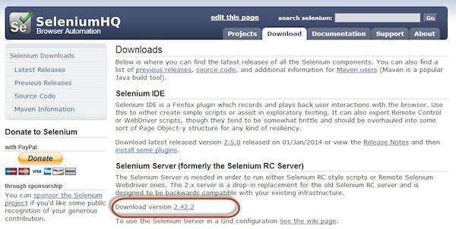

**Step 2**: After downloading, we need to start the Selenium Server. To do so, open command prompt and navigate to the folder where the downloaded JAR file is kept as shown below.

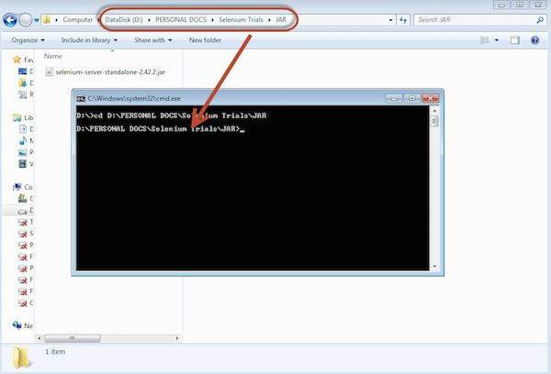

**Step 3**: To start the server, use the command 'java -jar <<downloaded jar name >> and if java JDK is installed properly, you would get a success message as shown below. Now we can start writing Selenium RC scripts.

